## ****Ameba如何更換DAP Firmware****

## ****如何更換DAP Firmware?****

要更換DAP firmware，請參考以下操作  
1. 按住CON2旁邊的按鈕不放  
2. 按一下CON1旁邊的按鈕  
3. 放開在第一步按住的按鈕

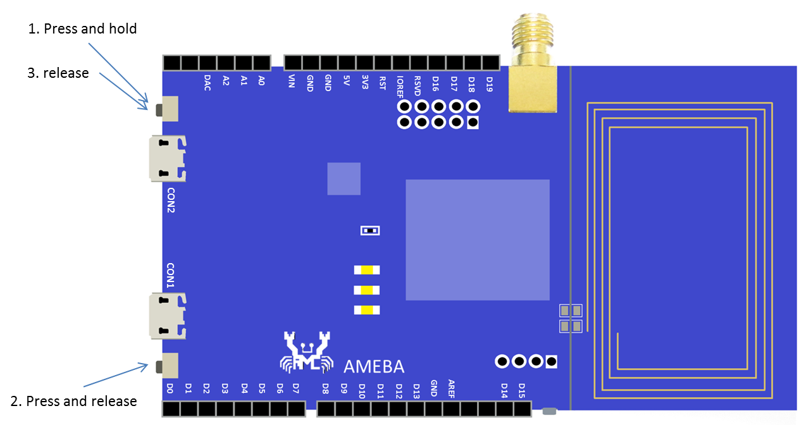

此時會出現一個磁碟槽，上面的標籤為 “CRP DISABLED”

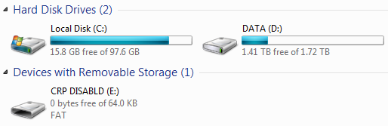

打開這個磁碟，裡面有個檔案 “firmware.bin”，它是目前這片Ameba使用的DAP firmware

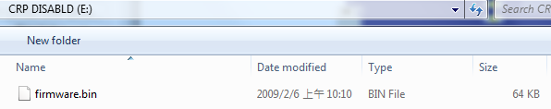

要更換firmware，可以先將這個 firmware.bin 備份起來，然後刪掉，再將新的DAP firmware用檔案複製的方式放進去

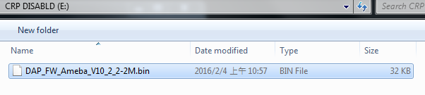

最後將USB重新插拔，新的firmware就生效了。

底下是目前的DAP firmware列表:

|  |  |  |
| --- | --- | --- |
| Version | Description | Link |
| DAP_FW_Ameba_V10_2_3-2M | 1. Improve upload speed. 2. Won’t restart DAP after upload finished. | [Download](https://github.com/Ameba8195/Arduino/raw/master/misc/dap_firmware/DAP_FW_Ameba_V10_2_3-2M.bin) |
| DAP_FW_Ameba_V10_2_3-2M_LED_Disable | 1. Improve upload speed 2. Won’t restart DAP after upload finished. 3. Turn off DAP LED. | [Download](https://github.com/Ameba8195/Arduino/blob/master/misc/dap_firmware/DAP_FW_Ameba_V10_2_3-2M_LED_Disable.bin) |
| DAP_FW_Ameba_V10_2_2-2M | 1. Won’t restart DAP after upload finished. | [Download](https://github.com/Ameba8195/Arduino/raw/master/misc/dap_firmware/DAP_FW_Ameba_V10_2_2-2M.bin) |
| DAP_FW_Ameba_V10_2_2-2M_LED_Disable | 1. Won’t restart DAP after upload finished. 2. Turn off DAP LED | [Download](https://github.com/Ameba8195/Arduino/raw/master/misc/dap_firmware/DAP_FW_Ameba_V10_2_2-2M_LED_Disable.bin) |
| DAP_FW_Ameba_V9_2-2M_Signature.bin | Check file extension and image signature | [Download](https://github.com/Ameba8195/Arduino/raw/master/misc/dap_firmware/DAP_FW_Ameba_V9_2-2M_Signature.bin) |
| 11u35_ameba_if_mbed_0_7_seperate | Original version | [Download](https://github.com/Ameba8195/Arduino/raw/master/misc/dap_firmware/11u35_ameba_if_mbed_0_7_seperate.bin) |